Cross members to be cut at 15.4 in to maintain floor size of 16 in

To bind cowl pieces, epoxy first, then silicone

https://www.testritealuminum.com/products/1_aluminum_rod_round_solid?variant=45251962536234

Cowl
- CAD
- Floor/Cowl Connectors
  - Flat
  - Scen1
  - Scen2
  - Scen3
  - Scen4
- Corners

- Materials:
  - Sheets: Dragon plate FDPLHP02S*TWL*901212
  - Floor/Cowl Connectors: Onyx 3D print
  - Corners: PLA
  - “Fabric”:
  - Epoxy:

Windshield
- Clear part of cowl is 3/16 in hard coated polycarbonate
- Hydraulic hinge for cowl: https://www.gasspringsshop.com/cart/
- 42 in x 21 in x 58.5 in triangle, height of 15.8 in
- 58.5 x 16
- Option 1
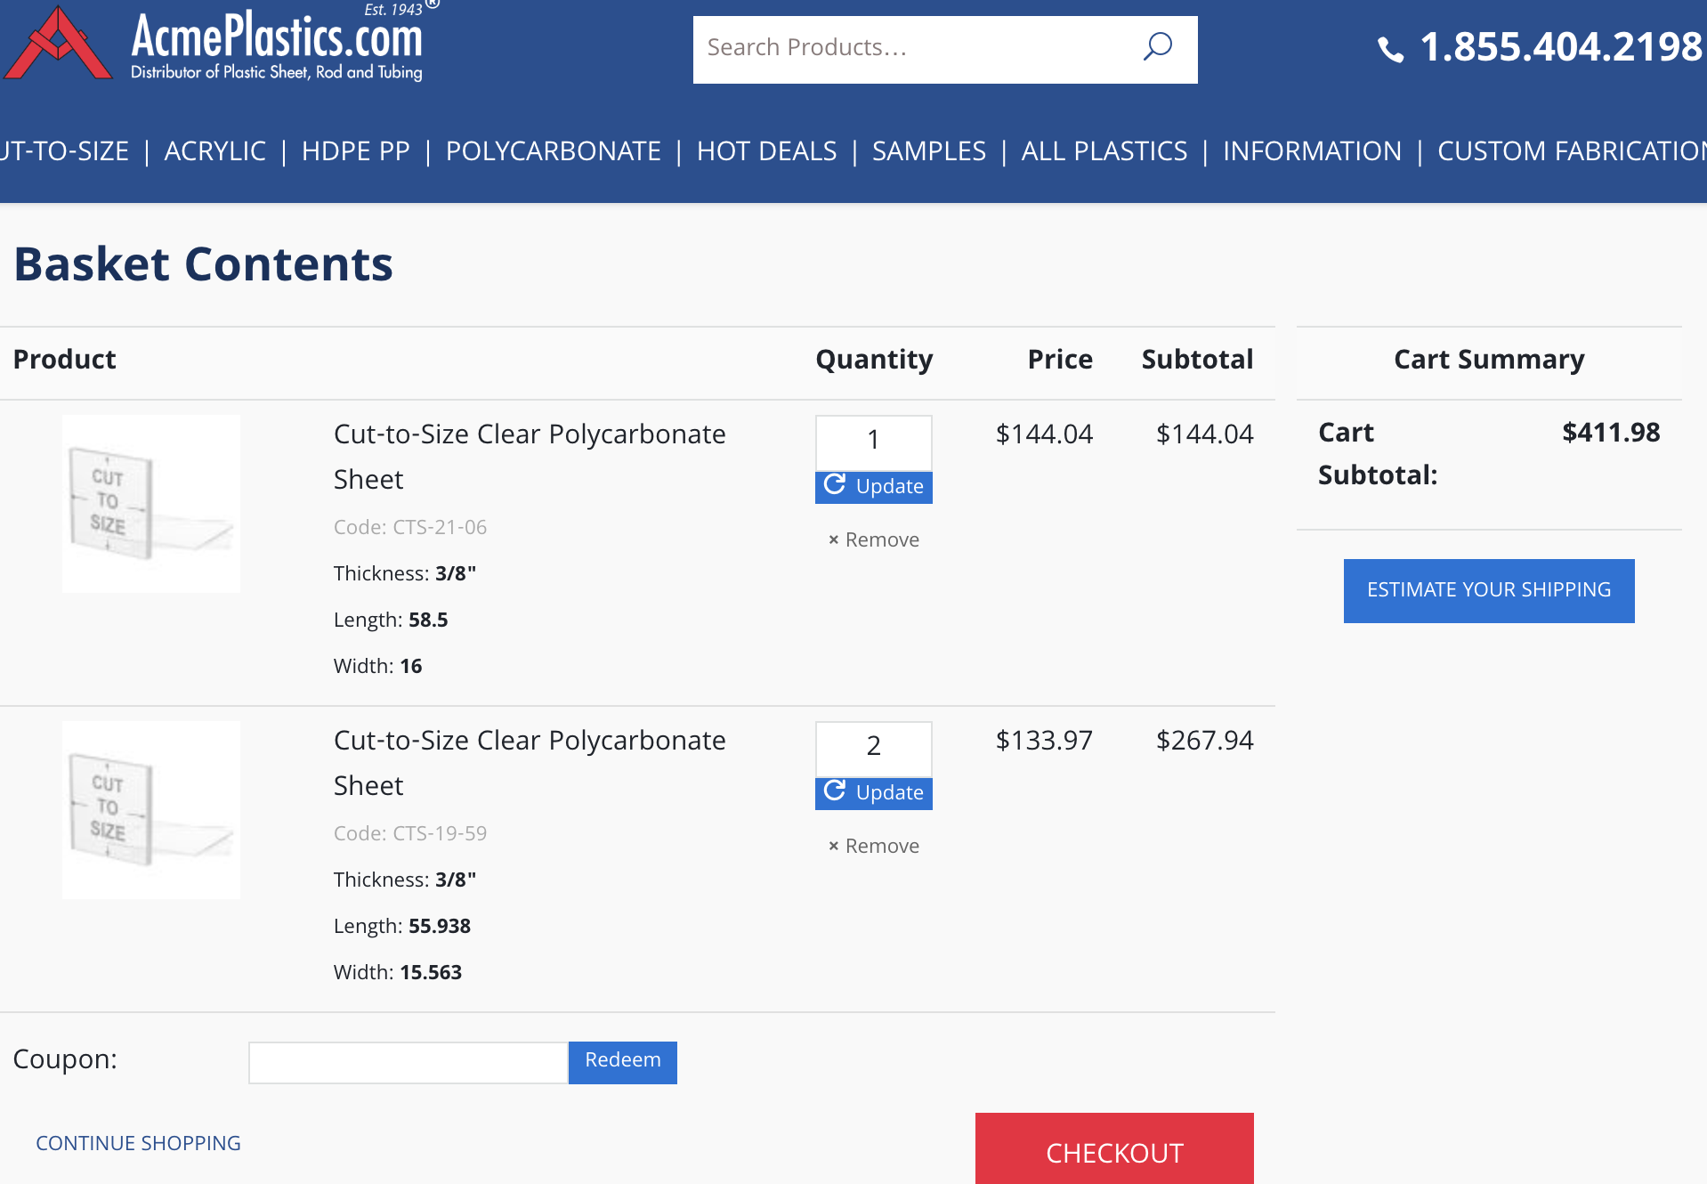
- Option 2: https://www.fixsupply.com/ps-pc-sr-5-scratch-uv-resistant-polycarbonate-sheet-3-8-thick-x-48-wide-x-96-long
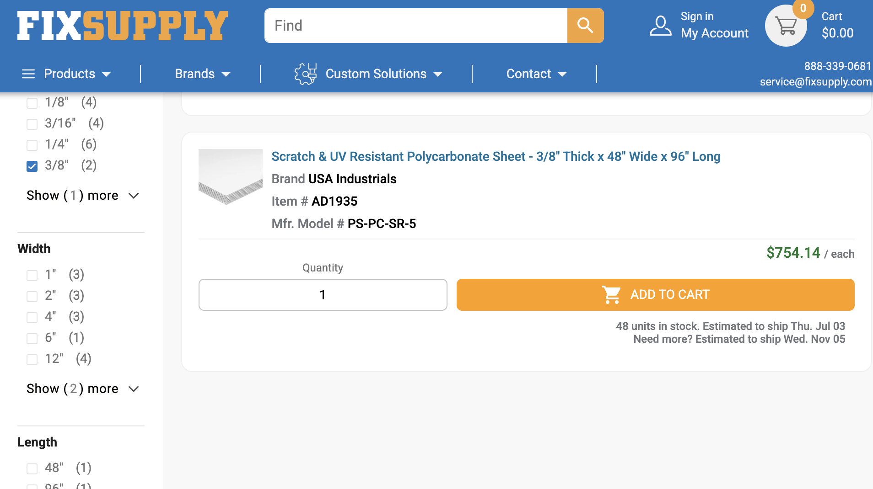
- Option 3: https://www.zoro.com/zoro-select-clear-polycarbonate-sheet-stock-96-l-x-48-w-x-0375-thick-ps-pc-sr-196/i/G3713376/
- 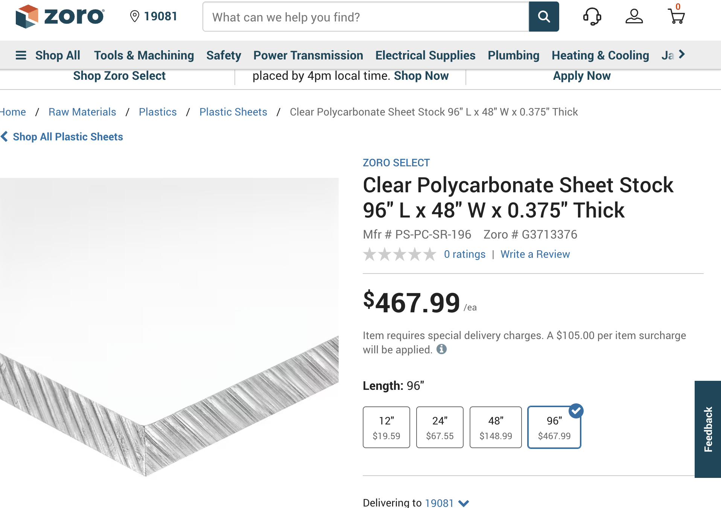
- Hardware

- 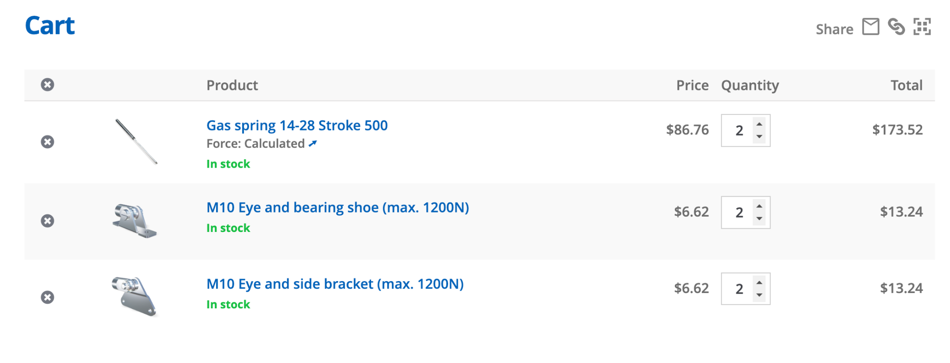
- Get foam tape for edge

The hydrogen issue
- Asked chem department
- Chem dept will likely buy it for us
- Just buy a new tank DO NOT bother with refilling

Brakes
- Tutorial
- Look at cad
- Josh says look at trike for tee connection and installation

Suspension
- OPTION? LINK

